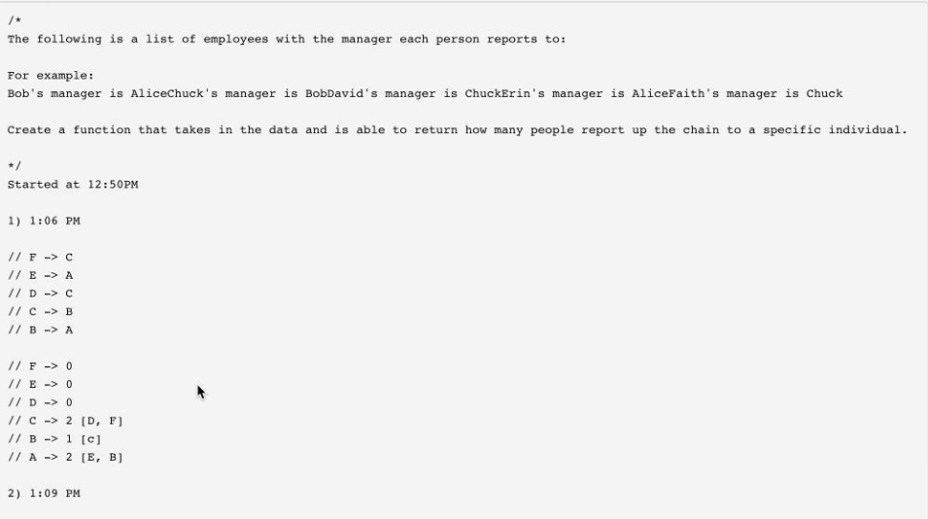

Tommy

sorted=> or not=> depending on that can check in middle or not

don’t ignore clarification questions,

---------
are right a lot:
data and analysis was not sufficient- example, matrix calculated risk,
difficult situation-time pm, mvp,
bad decision, -learning from it- missed dependencies
changelles faced

bias for action:
calculated risk, production release
manager not available, and you take

Customer obsession: never say anything negative
Customer wants something else, over and beyond to help customer:

Deliver results:
Challenge faced and how you overcome
obstalces

Dive deep:
high level, brainstorm sessions, layer by layer: big problem how will you solve, metrics based, how will you root cause analysis
Earn trust:
tough and critical feedback.
Have backbone:
Insist on high standards:
metrics point : insist on how talk about it,
Continous improvement
Documentation,
Invent and simplify:
come up simple solution, different process
chalennging problem and
Learn and be curious for change:
comfort area and liked it
changelling problem, more analysis,
Ownership:
long term goals while keeping short term commitments
-KT to other team members,
goal, peer to help

Think big:
never show long term goal was sacrified

Dextra technology, mexico

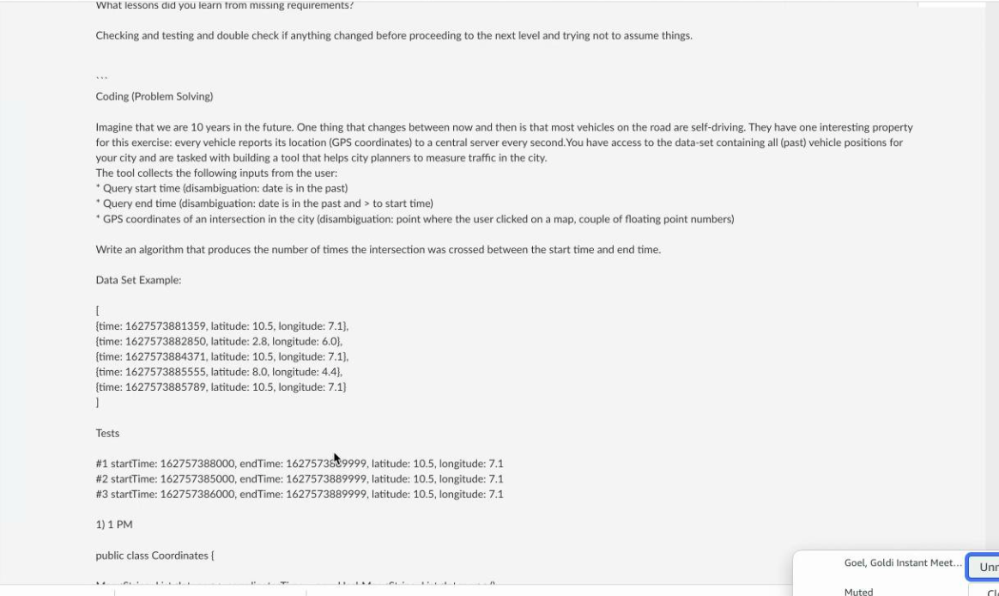

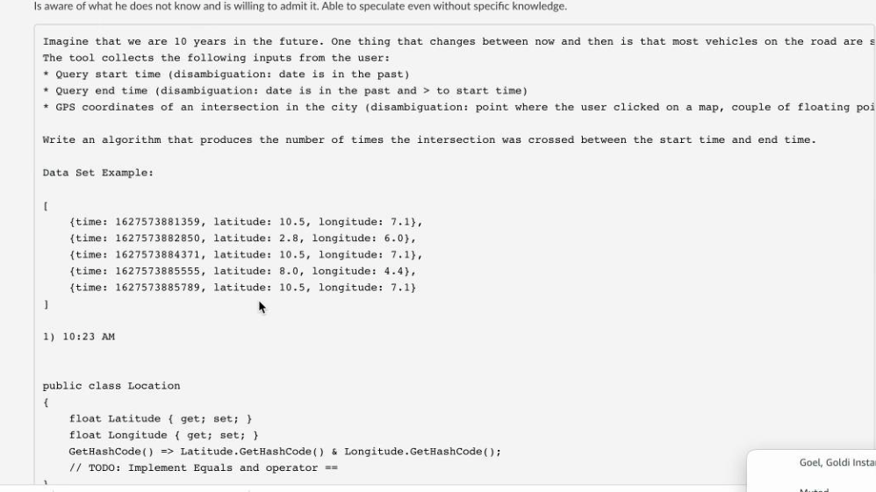

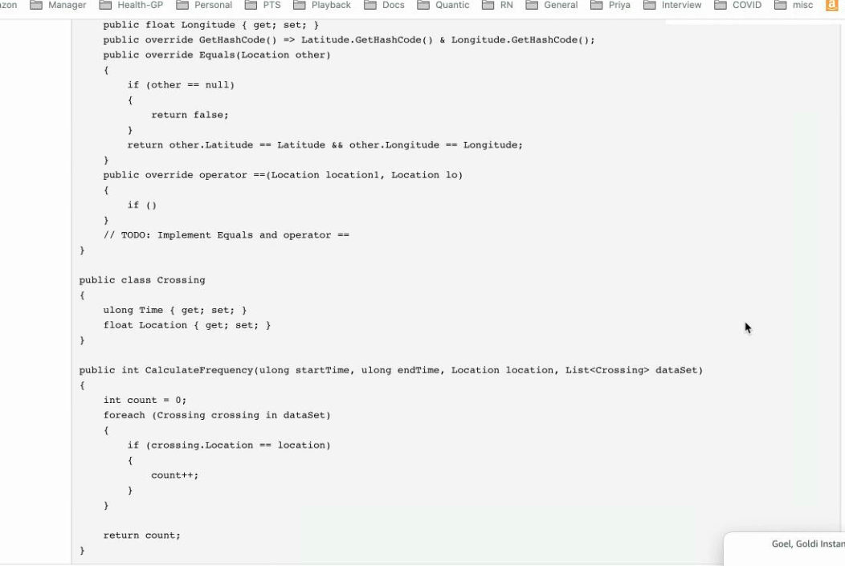

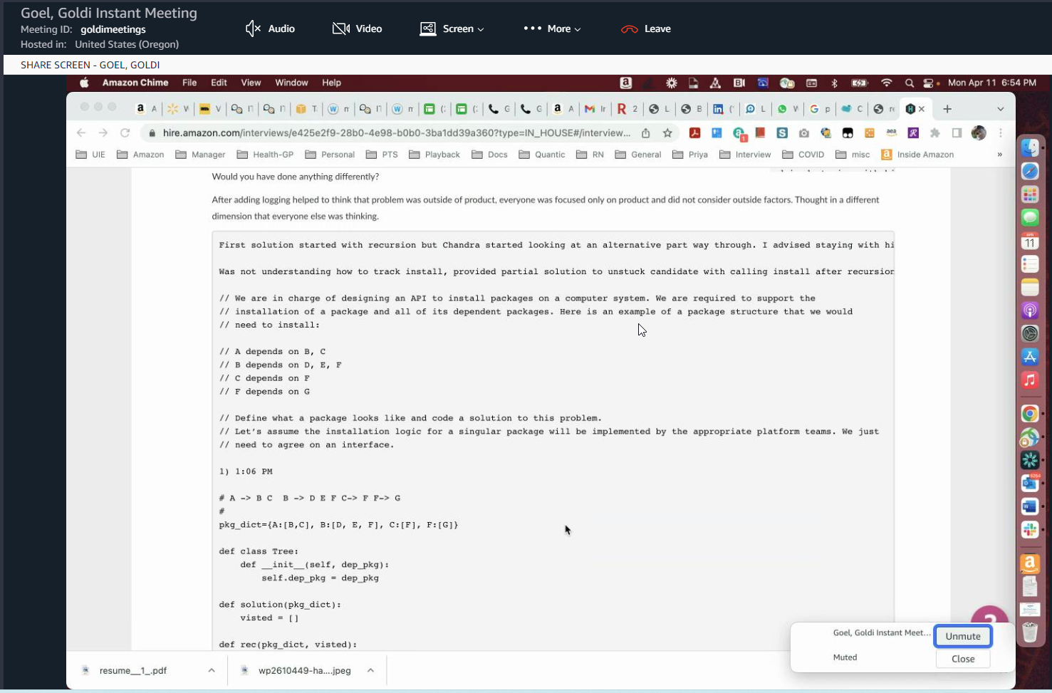
A
B C
D E F
G

